Central Database Repository Requirements

This Database will be used by JE specialists to do analysis among different types of positions. There are other databases that need to be loaded on to the repository Such as MJEP, MELS, OPSEU, PEGO etc. Then Use API calls to show the data that is requested.

**How to open the Tool:**

1) go to this link (if you cant access this link that means you don’t have access to DEV environment. Reach out to Charan for access) <https://make.powerapps.com/environments/9cc6d87e-a298-437b-a658-7f1b1dcada8f/solutions/332fb3b0-d417-ec11-b6e7-0022486dc930/objects/web%20resources>

2) click on test1.If it does not work then click on edit then this window will pop up. ( see picture below)

3) click on the highlighted link.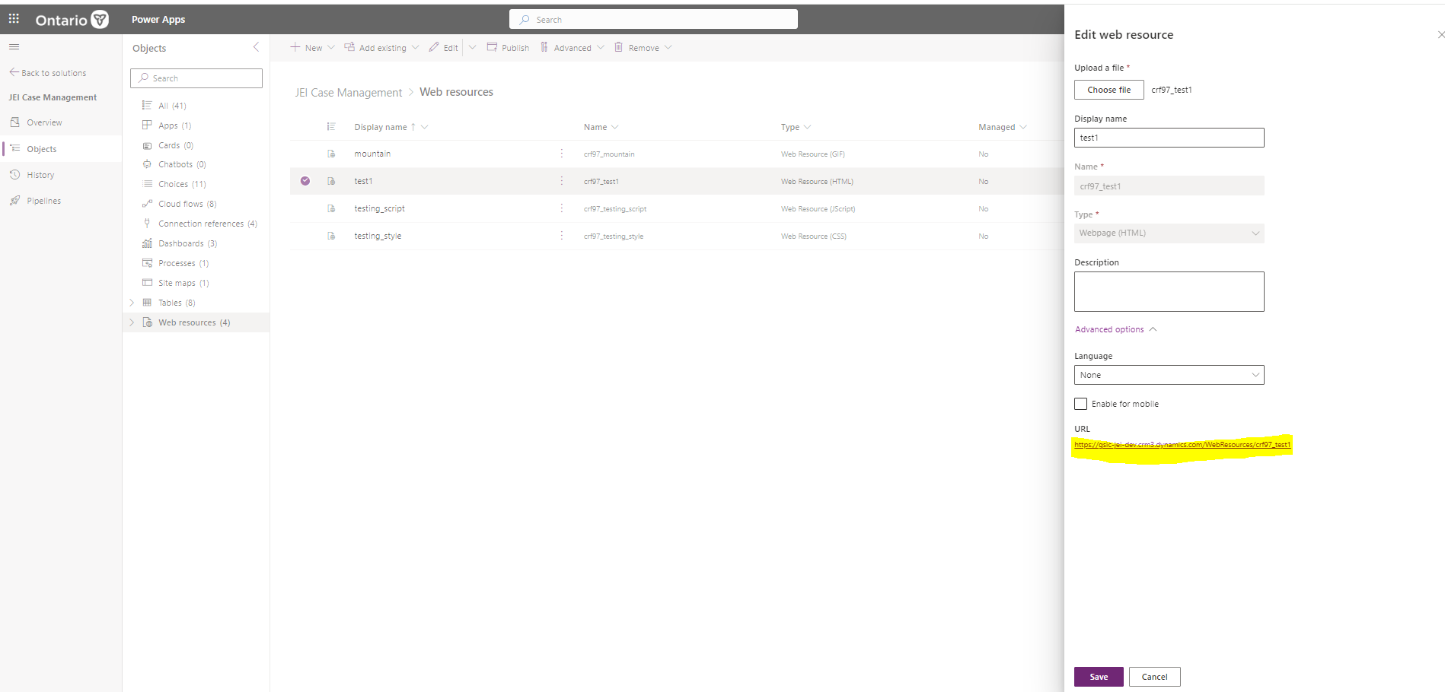

**How to load a new data:**

1) Go to this link <https://make.powerapps.com/environments/9cc6d87e-a298-437b-a658-7f1b1dcada8f/entities>

2)Click on import data.

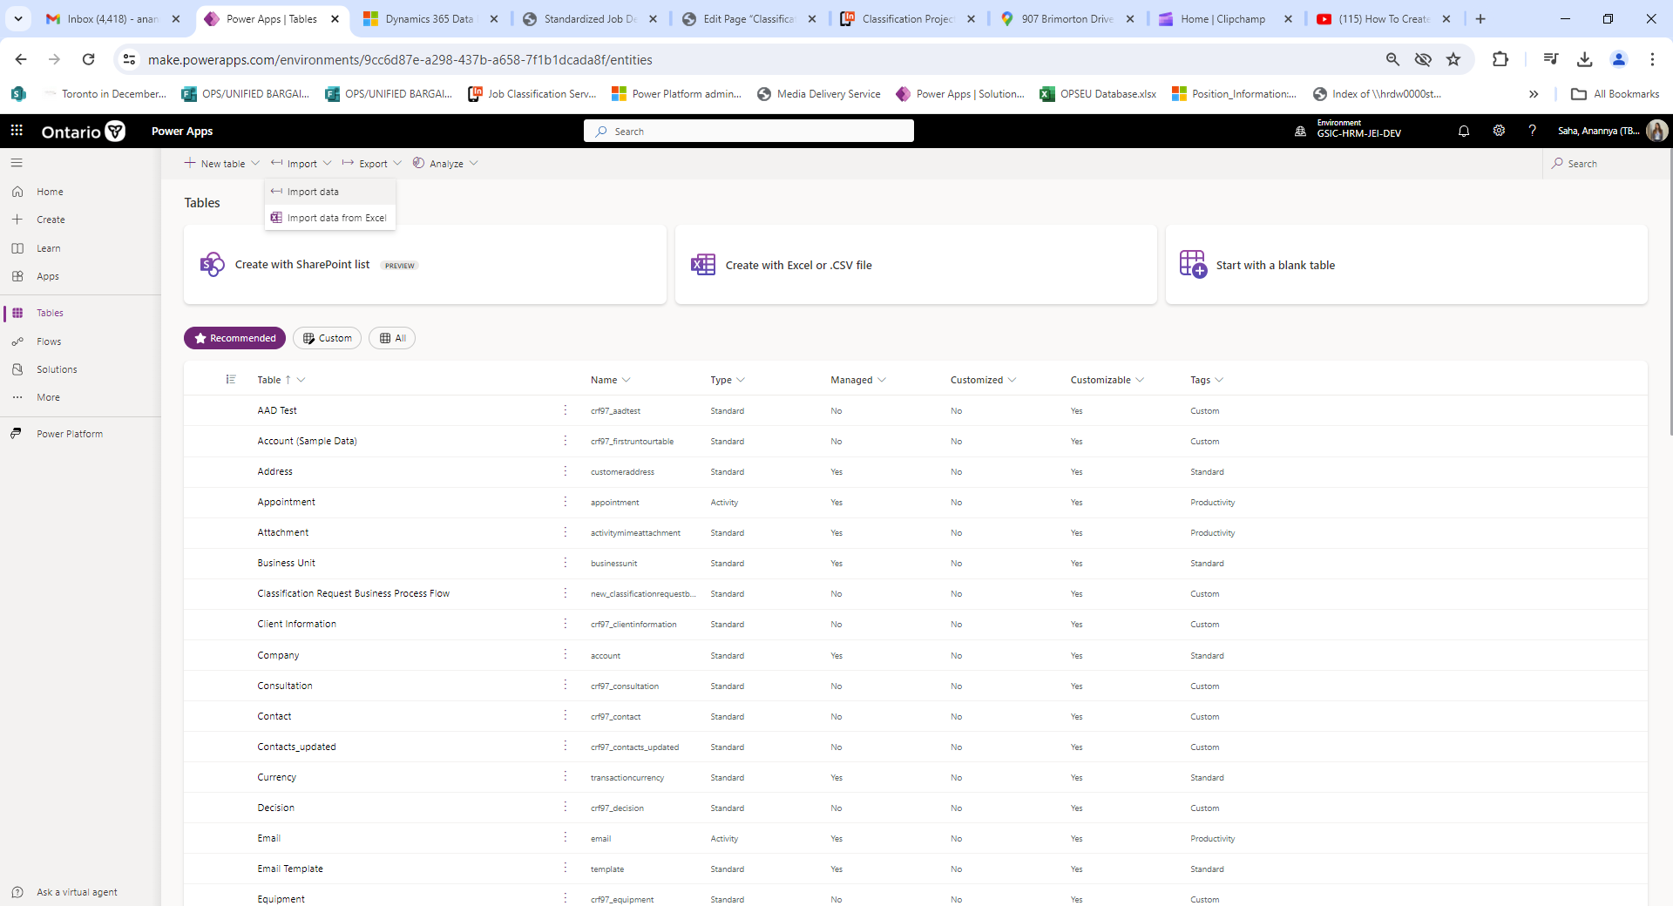

3) Select Excel workbook 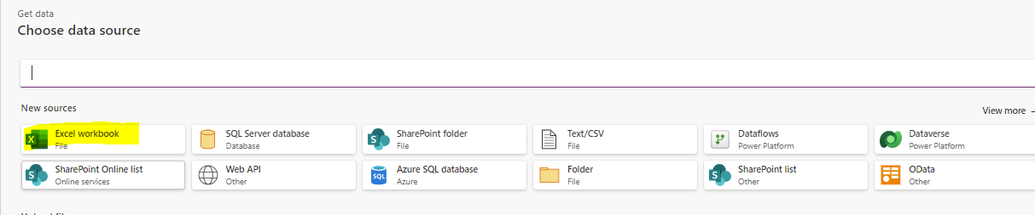

4) Select Upload File

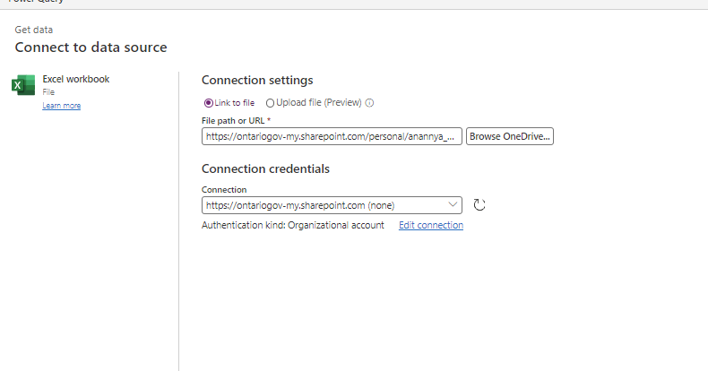

5) Select the workbook you want to load. Then Select Next.

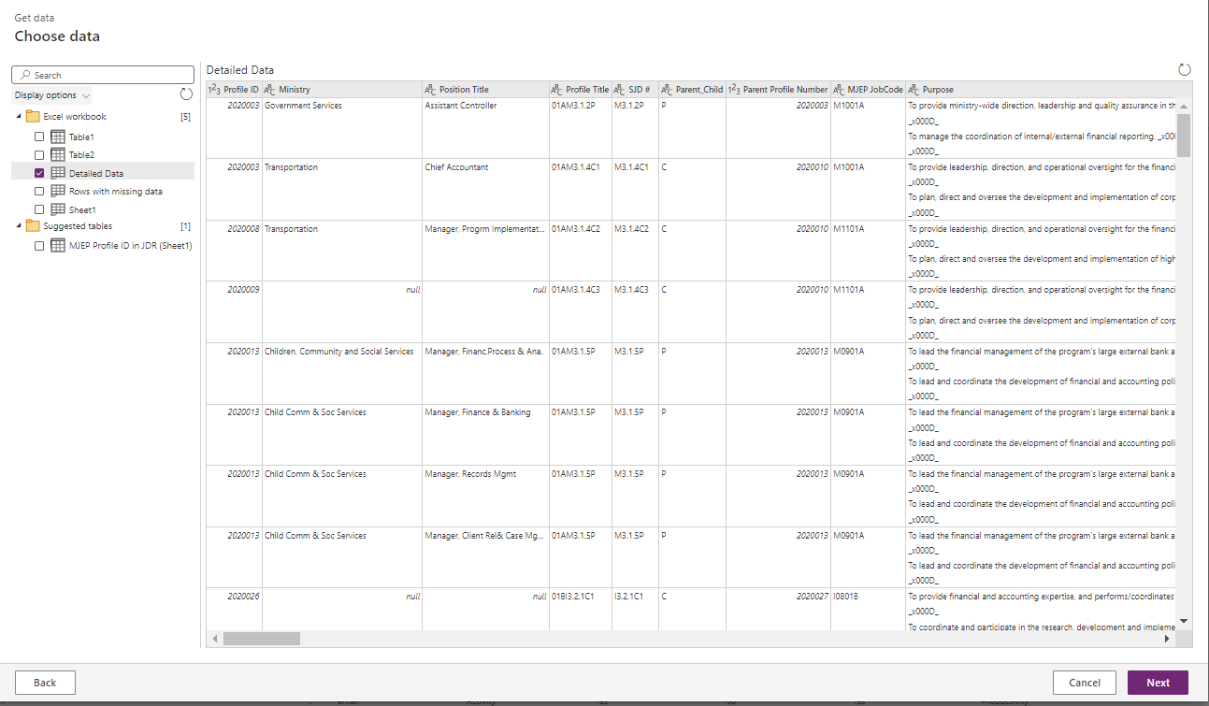

6) Remove the Changed column step

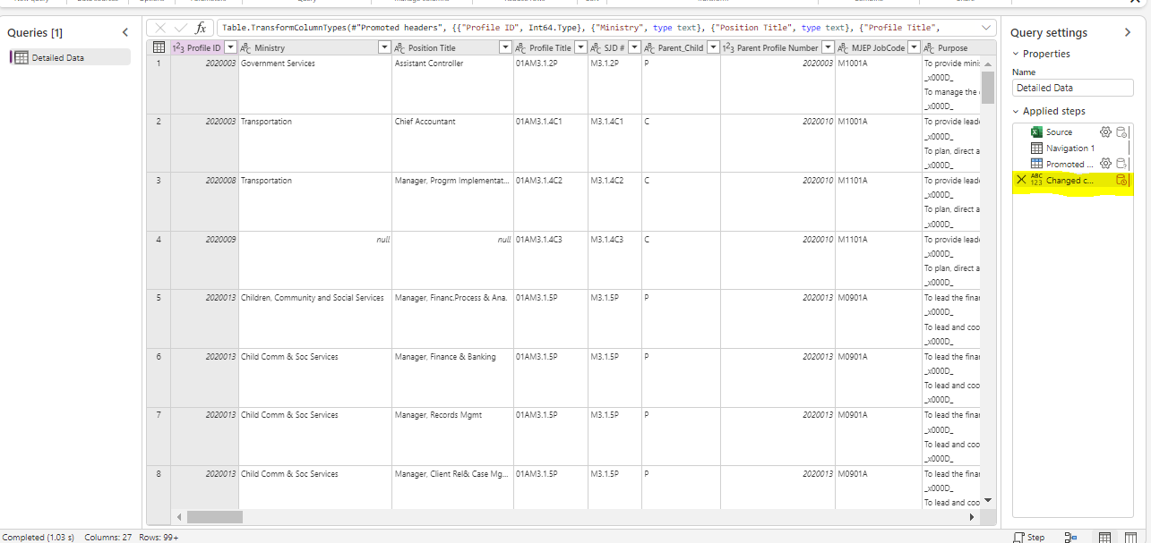

7) Select the load new table and then fix the data type.

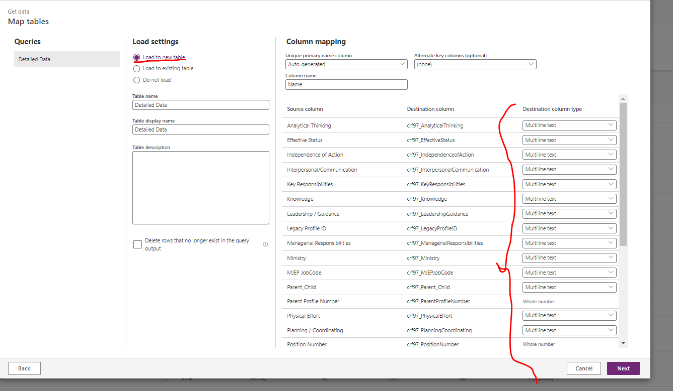

8) Click on publish now.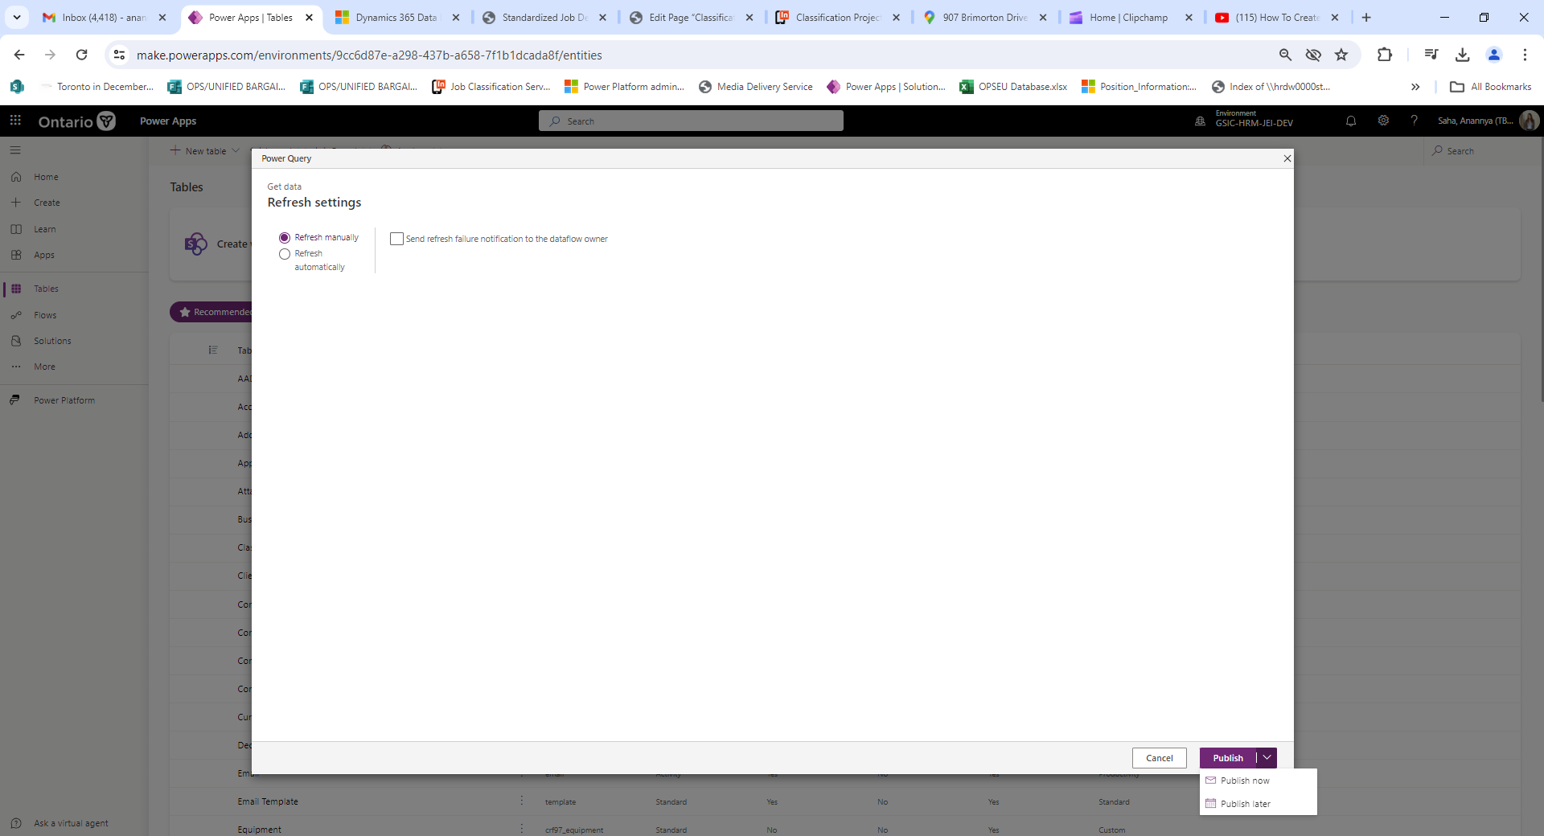

9) Then go to dataflow.

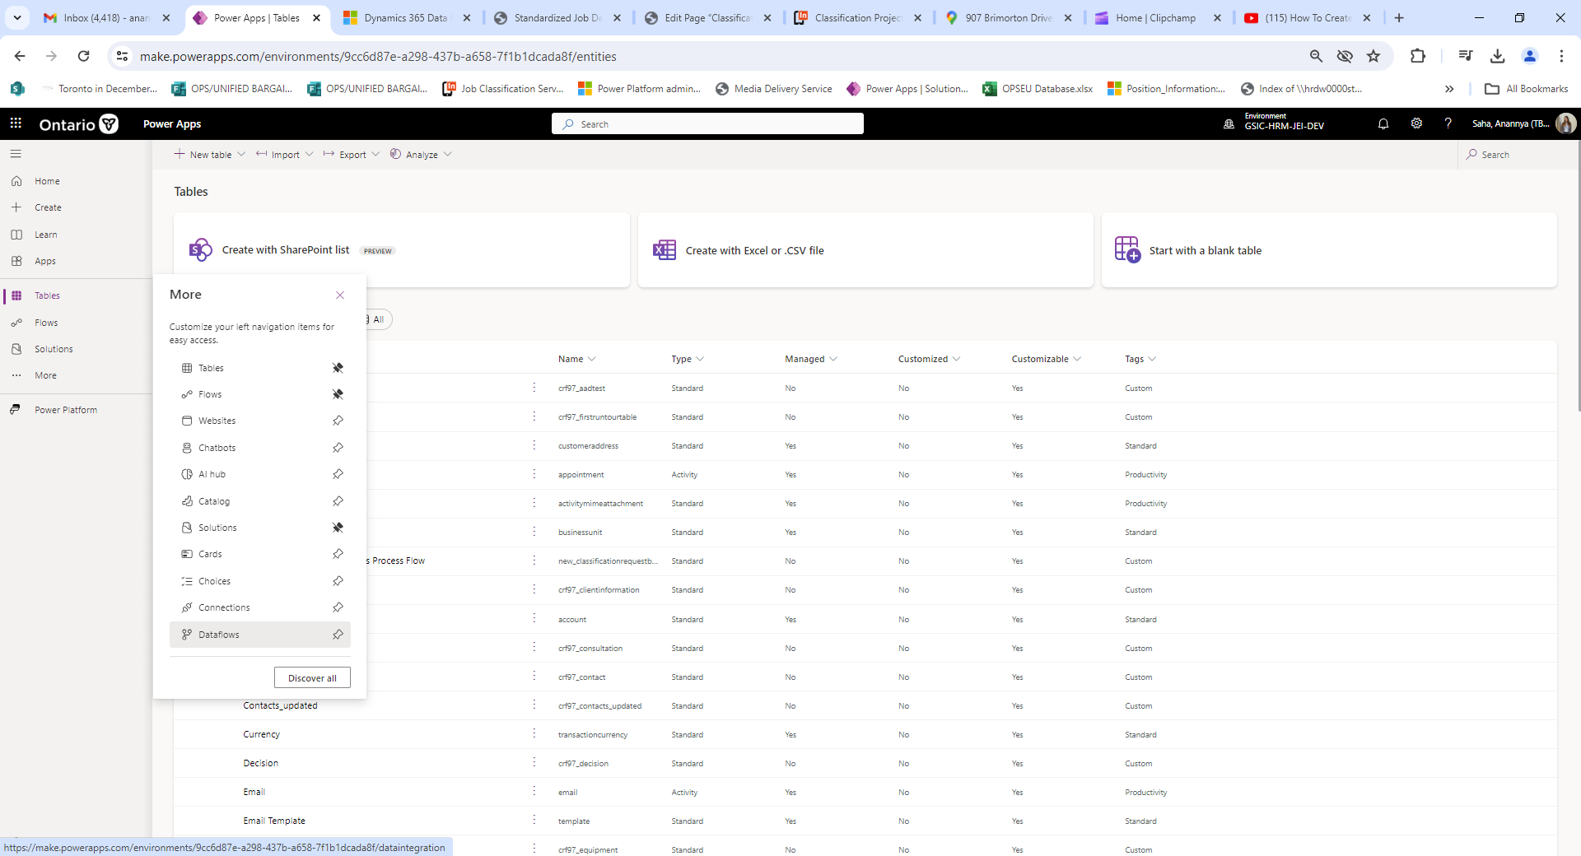

10)Then you should see the in progress

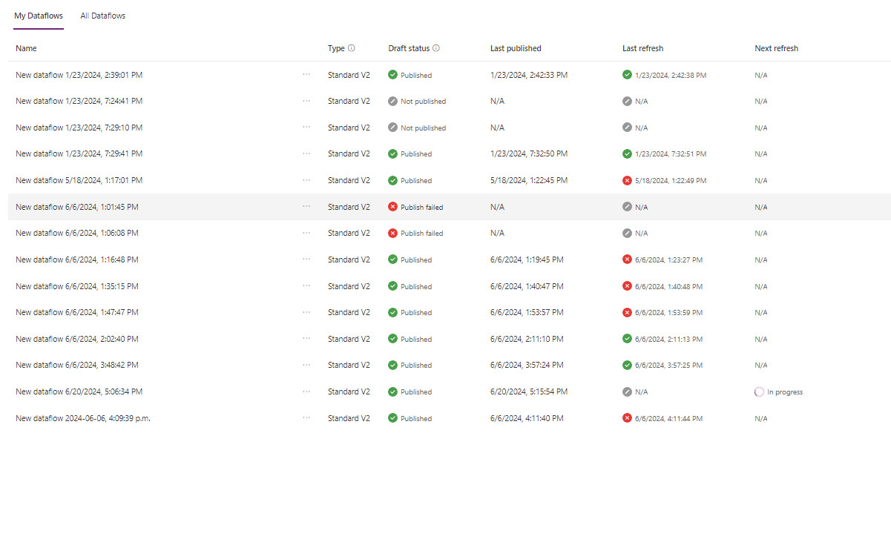

11) Then it has to be visible in this link <https://make.powerapps.com/environments/9cc6d87e-a298-437b-a658-7f1b1dcada8f/entities>

12) Click on it and find the API link as follows.

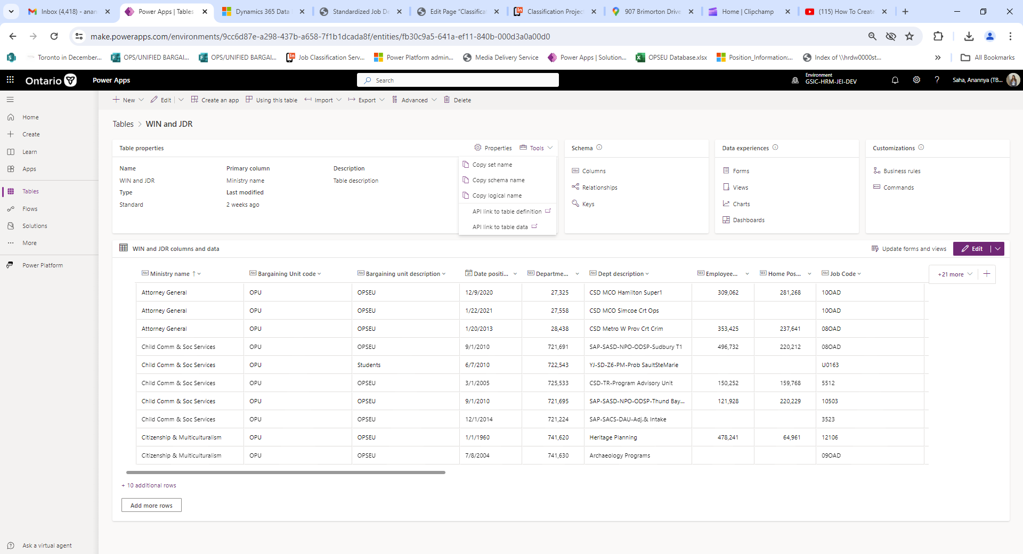

13) Use this API to load the data in CDR (Central Database Repository). It should show only first 5000 rows. Please look at my code (used in the CDR script file) below to load all the data. If this process don’t work then repeat the process of loading data in Microsoft edge.

nextUrl = apiUrl

    while (nextUrl) {

        const response = await fetch(nextUrl, {

            headers: {

                'Prefer': 'odata.include-annotations="OData.Community.Display.V1.FormattedValue"',

                'OData-Version': '4.0'

            }

        });

        if (response.ok) {

            const jsonResponse = await response.json();

            full_data = full_data.concat(jsonResponse.value);

            nextUrl = jsonResponse['@odata.nextLink'];

        } else {

            throw new Error(`Failed to fetch records:${response.statusText}`);

        }

    }

**Currently Implemented:**

* WIN and JDR data is loaded
* The filtering functions are completely implemented.
* Download button is implemented.
* Restart button is implemented.

**Future Implementations:**

1) Bring alternative colors to the table like excel

2) Freeze the first row of column names for easy visibility

3) Add the number of rows loaded in table in one corner so that user can understand how many rows have been loaded.

4) Load MJEP, MELS, OPSEU, PEGO database in dynamics 365

5) Implement highlight option so that row or column or cell can be highlighted. When downloaded the highlight stays there too.

6) Ability to merge the MJEP database with WIN and JDR or MELS with WIN and JDR etc using the position number field.